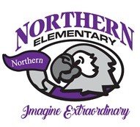

Northern Elementary

2024-2025

**1st Grade Supply List**

*Label with your child’s name

* **Primary Journal** – Draw Space on top /Lines on the bottom*
* Composition Book – **Wide Ruled** – Black Marble*
* **Plastic** Pocket Folders – Blue, Purple, Red, Yellow*
* Headphones *
* Crayola Crayons – 24 count – 2 boxes*
* Expo Dry Erase Markers – 4 pack
* 24 Pencils – Ticonderoga Recommended - Sharpened
* Erasers – Large Pink – 2 count
* Washable Elmers Glue Sticks – 12 count
* Scissors – Fiskars 5 inch – Blunt tip*
* Pencil **Box** – plastic*
* 2 Large boxes of tissues
* Disinfectant Wipes – Large

***Optional Items – Not required but appreciated***

* Ziploc Bags – Quart / Gallon
* White Cardstock
* White Copy Paper Ream
* Baby Wipes
* Sheet protectors
* Laminating Pouches
* Ipad Pen / Stylus

Please bring your child’s supplies to our Open House